**8.6 Combination and Composition of Functions**

**Function Notation Review**

Find the corresponding outputs or inputs for the following functions.

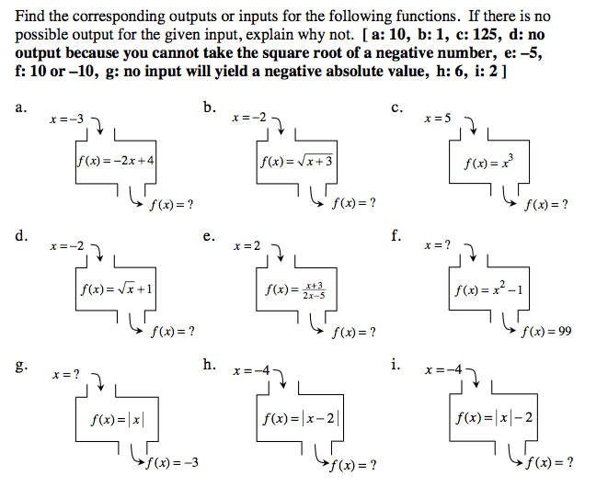

**Combination of Functions**

Use the following functions for examples 1-3:

4

1. 2. 3.

**Composition of Functions**

When the output of a function depends on an ________ that is itself the ________ of another function

*Compute*  *in two different ways given* *and*.

|  |  |
| --- | --- |
| 1. Find: 2. Find : | 1. Find: 2. Find : |

|  |  |
| --- | --- |
| **Composition**  =  = | **Explanation**  Find $g(x)$. Then use that output to find $f(x)$.  Find $f(x)$. Then use that output to find $g(x)$. |

**Use the following functions for examples 1-2:**

$f\left(x\right)=2x+1$ $g\left(x\right)=-4x$ $h\left(x\right)=x^{2}-5$

1. Compute or find. 2. Compute or find .

Now find $(f∘g)(n+2)$ Now find $\left(f∘g\right)\left(\frac{l}{2}\right)$