8.4 “plugging in x” with Function Notation
When looking at the function $f\left(x\right)=4x$ you know that we have seen $f(x)$ as _______________. What if you saw this: $f\left(x\right)=2x+7$ what is $f(3)$?

Practice that same strategy for the following:
- $f\left(x\right)=x^{3}+4-7x$  - $f\left(5\right)=$  - $f\left(-2\right)=$  - $f\left(21\right)=$ | - $f\left(x\right)=4x^{2}-2x$  - $f\left(0\right)=$  - $f\left(2\right)=$  - $f(-21)$

Now for each of the above write what the coordinate pair is:
- Using the above from problem 1. | - Using the above from problem 2.

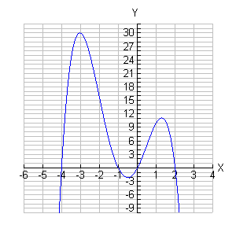
Use the graph the left to identify the indicated point:
- $f\left(0\right)=$
- $f\left(-3\right)=$
- $f\left(2\right)=$
- $f\left(-1\right)=$
- $f\left(1\right)=$

