7.3 Domain and Range: Inequalities
Describe the domain and range for each function using set notation and interval notation.
***Remember***
A closed dot indicates ___ or ___ when using inequalities
and _________________ when using interval notation.
An open dot indicates ___ or ___ when using inequalities
and _________________ when using interval notation.
- 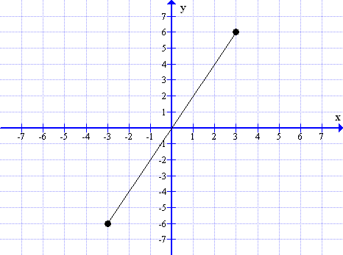  Inequality Interval Notation  Domain  Range | - 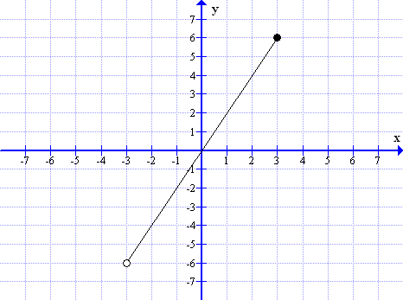  Inequality Interval Notation  Domain  Range
- 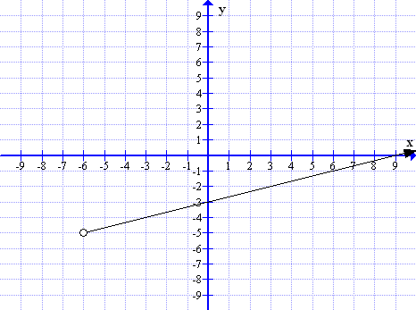  Inequality Interval Notation  Domain  Range | - 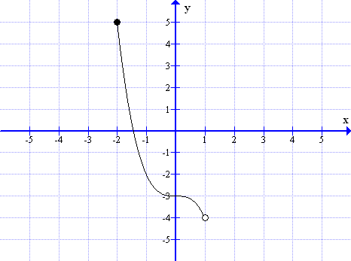  Inequality Interval Notation  Domain  Range
- 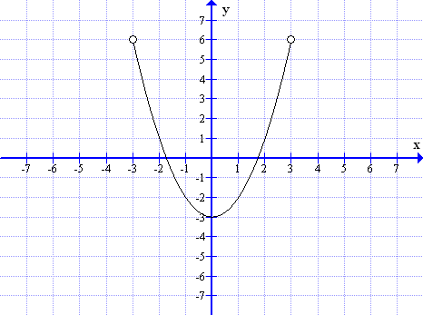  Inequality Interval Notation  Domain  Range | - 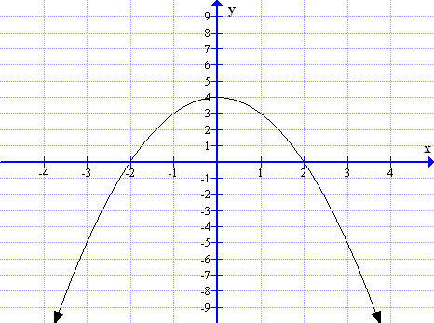  Inequality Interval Notation  Domain  Range

