Name: _________________________________________________________ Date: _____________________________ Per: __________
5.3B Solving Systems of Equations by Substitution
Directions: Use substitution to solve each system of equations. Write your answer as an ordered pair. SHOW ALL YOUR WORK!!!
Example 1 Step One
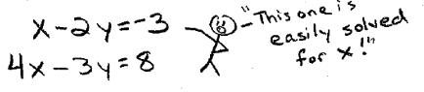
Step Two
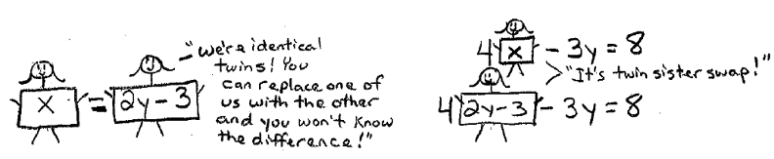
$x-2y=-3$
$$4x-3y=8$$

Step Three
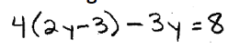
Solve the equation with the substituted value…
Step Four
Take your answer and plug it any equation to find the last variable
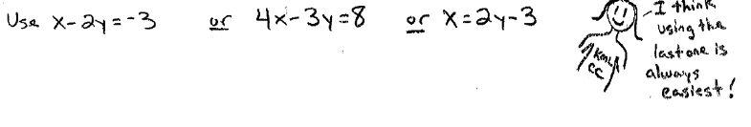

Ex. 2  x -2y = 0  3x + 3y = 18 | Ex. 3  x + y = -6  5x + y = -13 | Ex. 4  3x – 4y = 2  -3x + 3y = -3

