Name: _________________________________________________________ Date: _____________________________ Per: __________
5.3A Notes Solving Systems by Substitution
Directions: Use substitution to solve each system of equations. Write your answer as an ordered pair. SHOW ALL YOUR WORK!!!
Example 1
Step One
Substitute the _______________ to the solved ____________ I for that variable in the other ___________________.
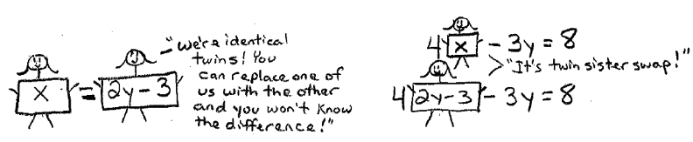
$x=2y-3$
$$4x-3y=8$$

Step Two
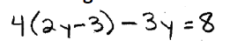
Solve the equation with the _____________________ value…
Step Three
Take your answer and ___________ it any _________________ to find the last __________.
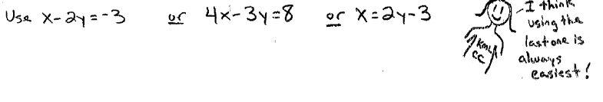

Ex. 2  $y-7x= - 10$  $$y = -3$$ | Ex. 3  $x = -8$  $$2x + y = -12$$ | Ex. 4  $y = 6x$  $$y = 5x+7$$
1.$y + 9 = 9x$  $$y = 9$$ | 2. $x = -4$  $y = -x – 8$ | 3. $y = 8x – 9$  $$y = 7$$
4. $x – 6y = -14$  $$x = -8y$$ | 5. $y = 2x – 15$  $$y = 5x$$ | 6. $y = -8x$  $$2x + 4y = 0$$
7.$-4x + y = 6$  $$-5x – 21 = y$$ | 8. $-7x -2y = -13$  $$x = 2y + 11$$ | 9. $-3x + 3y = 4$  $$y = x + 3$$

