5.1 Graphing Systems of Inequalities
Steps for graphing inequalities:
1. (to fill in blanks see http://www.pinterest.com/pin/81416705735127369/)
2.
3.
4.
Example 1:
$$y<\frac{-1}{2}x+3$$
$$y>2x-2$$

Solutions
SOLID LINE
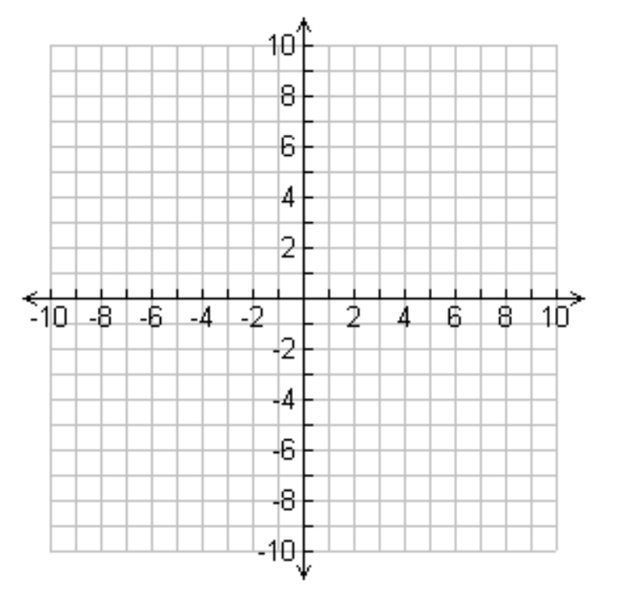
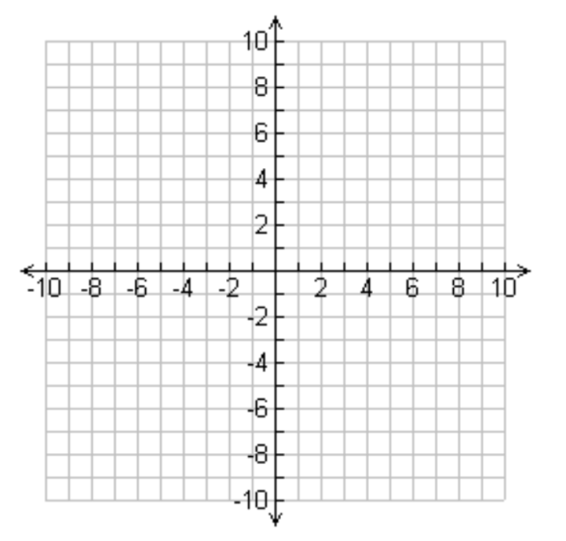
Example 2:
$$x+y≤-2$$
$$5x+y<2$$

Solutions

SHADING
Above

Below
DASHED LINE

5.2 Graphing Systems of Inequalities
Steps for graphing inequalities:
1.
2.
3.
4.
Example 1:
$$y<\frac{-1}{2}x+3$$
$$y>2x-2$$

Solutions
SOLID LINE
Example 2:
$$x+y≤-2$$
$$5x+y<2$$

Solutions

SHADING
Above

Below
DASHED LINE

