Name ____________________________________________ Date ______________ Period ____________

Systems of Equations

Graph the following lines and decide the type of system and number of solutions.
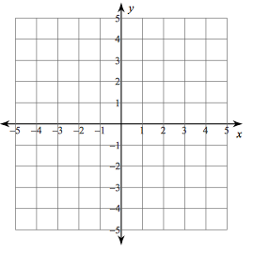
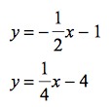
1)
Type of system:

Number of Solutions:

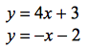
2)
Type of system:

Number of Solutions:

3)
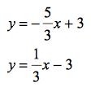
Type of system:

Number of Solutions:

