4.4 Graphing Linear Inequalities
Inequality | Line | Shading
$$y>$$
$$y<$$
$$y≥$$
$$y≤$$
Graph the following and decide if the given point is an answer to the inequality.

- $y≤\frac{5}{3}x-2$ (0,0)  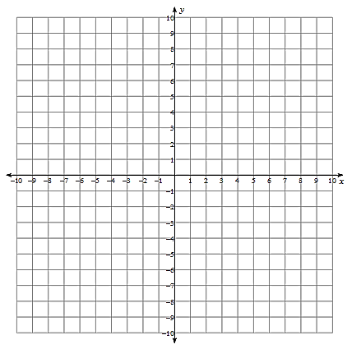 | - $y<-\frac{9}{2}x-4$ (2,-3)

