4.3 Graphing Linear Equations
$$y=mx+b$$
$↑ ↑$
$m=$_________________(Move)
$b=$___________________ (Beginning)
Graphing an equation in Slope intercept form you use the following steps:
- ____________________ for ________
  - First _____________________ the _____________________
  - Second ____________________ by the _________________ of ________
- _____________ at the ___________________
- Find more points by using the _____________________________________
- Connect the dots with a ________________________________
Use the above to solve the following:
- $y=-x+5$  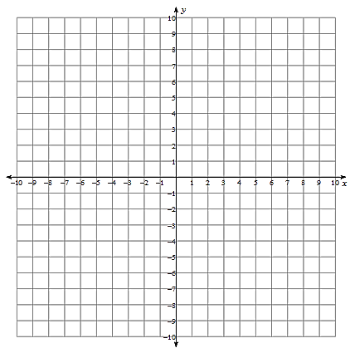 | - $7x-4y=-16$

