4.2 Graphing Linear Equations A.CED.2
$$y = mx + b$$
$↑$ $↑$
$m$=__________________ (Move)
$b$= __________________ (Beginning)
Solve the following for y, then graph. Decide if the coordinate pair given is a solution:
- $4x-y=0$  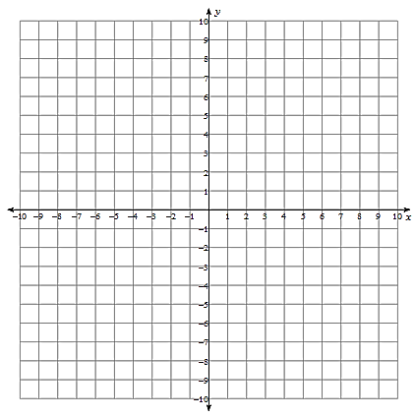 | - $x=3y=9$

- $5x-3y=3$ | - $x=-5$

